Virtual Advocacy Day Toolkit For Community Schools

April 29, 2015



Sample Facebook Posts

Choose the one that resonates most with you and your community. Please post directly on your legislators’ or governor’s Facebook page. Also, use #communityschools, #TeenREACH, #twill, #saveafterschool, and #afterschool in your posts. If you are posting on a member of the Senate Appropriations 1 Committee page, use #SenAppri1 in your post.

Sample Facebook Post 1

#Afterschool programs, like #TeenREACH, keep kids safe and engaged. Why then are these programs deemed “nonessential”? Thousands of youth and families are being affected by these cuts. We urge you to #saveafterschool in #Illinois.

[Add the image below to your Post!]
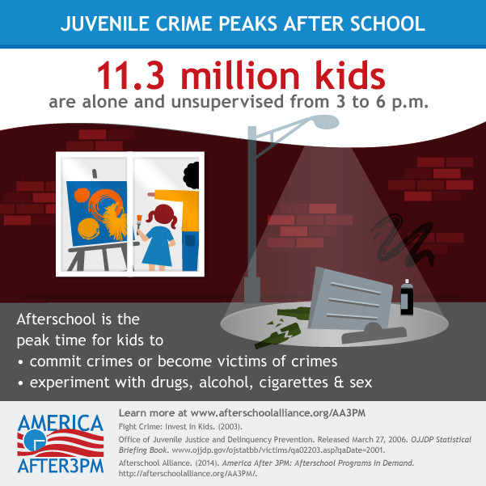

Sample Facebook Post 2
#TeenREACH keeps youth safe and supports working families. In #Illinois 65,000 students and 11,000 adults count on #afterschool programs each day. #Saveafterschool #Communityschools do matter.
[Add the image below to your Post!]
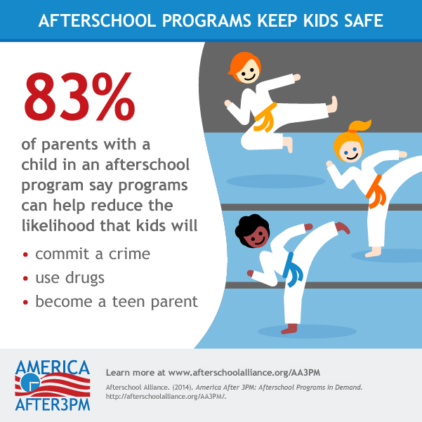

Sample Facebook Post 3
According to The Chicago Tribune | April 4th 2015
Governor Rauner’s $26 million cut will save Illinois millions. But constituents are paying the price. Jimi Orange of Children's Home and Aid faces the unenviable task of telling up to 25 of the 100 children in Chicago's impoverished West Englewood neighborhood they can't come to Earle Elementary School for after-class tutoring and cultural activities because the state has recalled the remaining $3.1 million of #TeenREACH money for kids ages 7 to 17.

Let’s not close this door to the youth and families who need these resources the most. #SaveAfterschool #Communityschools matter!
Sample Facebook Post 4
I condemn Governor Rauner’s reckless grant terminations that close doors to thousands of children & families. Cuts to #afterschool programs increase delinquency and make kids feel less safe. #Saveafterschool #TeenREACH
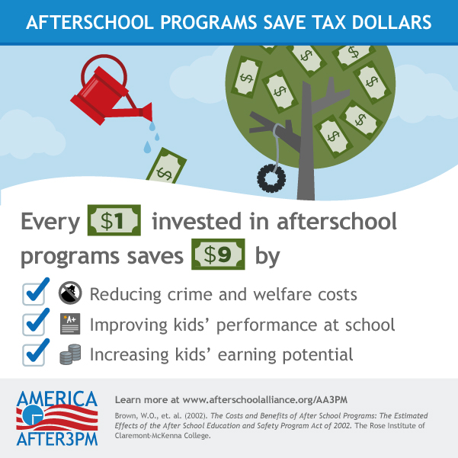
[Add the image below to your Post!]

